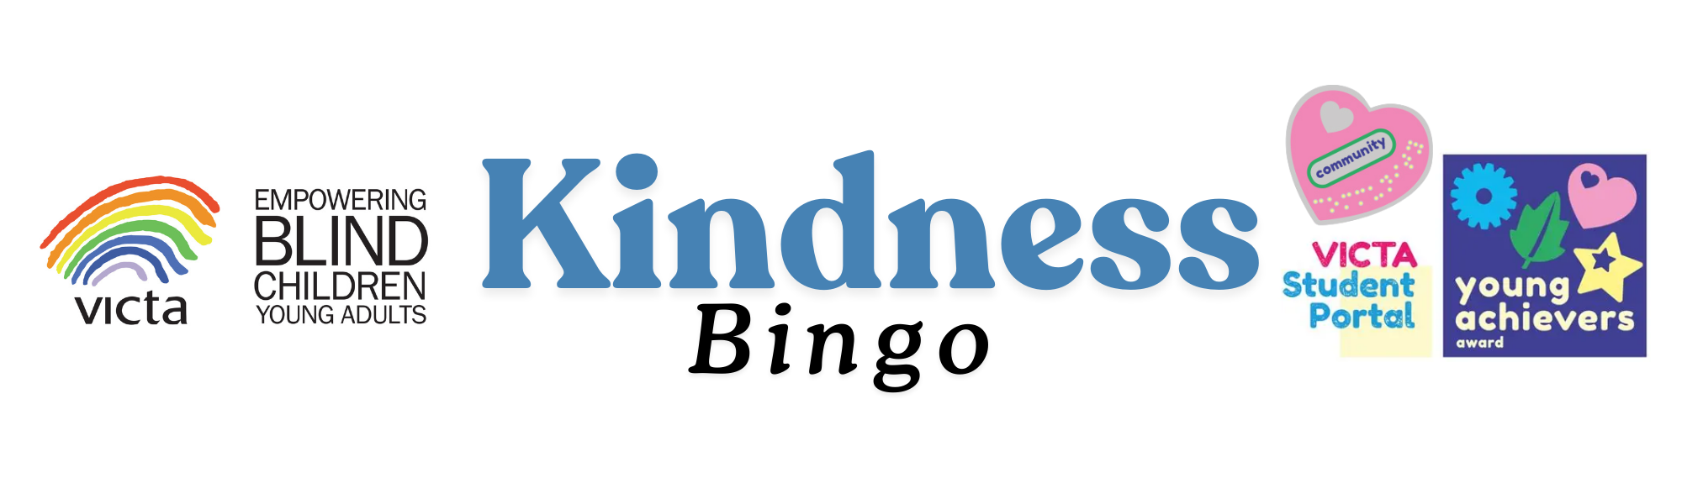
Ask someone new to play at break time | Hold the door open for someone | Write a kind note to your mum or dad | Let your brother or sister play with one of your toys | Give someone a compliment
Leave a kind note in a library book | Clean up your room without being asked | Smile at someone that walks past you in the street | Create a picture and give it to a friend or neighbour | Give a hug to each member of your family
Choose an area to pick up litter | Tell your parents you love them | 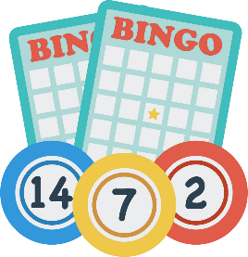 | Tell a joke | Write a kind note to your teacher
Say thank you to the bus driver and lunch ladies | Teach someone something new | Compliment a stranger | Put your plate in the dishwasher after eating | Call your Grandma or Grandad just to say hi
Donate clothes you have outgrown | Write a kind note to a classmate | Put every item you use in the recycling bin | Listen to a friend’s story without telling your own | Give high-5’s today!

